Road Accident Report SQL Queries

CY Casualties:

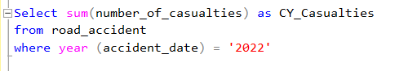



CY Accidents:





CY Fatal Casualties:

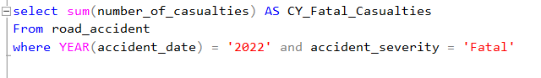

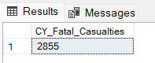

CY Serious Casualties:

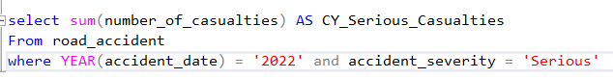

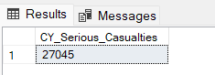

CY Slight Casualties:

